**Post Management:**

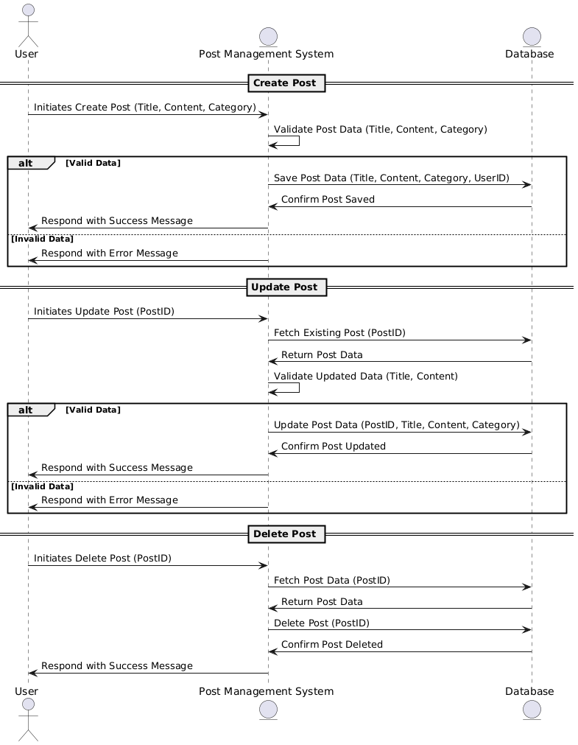

**Database:**

**Functional Requirements (FRs)**

**Post Creation:**

* **FR1:** Users must be able to create posts with a title, content, and timestamps (created_at, updated_at).
* **FR2:** Each post must be associated with a user (the creator of the post).

**Post Editing:**

* **FR3:** Users must be able to edit their own posts (title, content, tags, etc.).
* **FR4:** The system must log the history of changes made to a post, including who made the change and when.

**Post Deletion:**

* **FR5:** Users must be able to delete their posts.
* **FR6:** The system must confirm that a user wants to delete a post to prevent accidental deletions.

**Commenting on Posts**:

* **FR7**: Users should be able to comment on posts.
* **FR8:** Users should be able to edit and delete their comments.

**Non-Functional Requirements (NFRs)**

* **NFR1:** The system should be able to handle at least 5,000 posts and 100,000 comments concurrently with minimal latency.
* **NFR2:** Post creation, editing, and deletion should be processed within 2 seconds for a smooth user experience.

**Usability:**

* **NFR3**: The user interface for post creation, editing, and commenting should be user-friendly and intuitive.
* **NFR4:** The system should provide a preview feature before posting or editing content.
* **NFR5:** The system should be mobile-friendly to allow users to manage posts and comments on various devices.

**Announcements Management:**

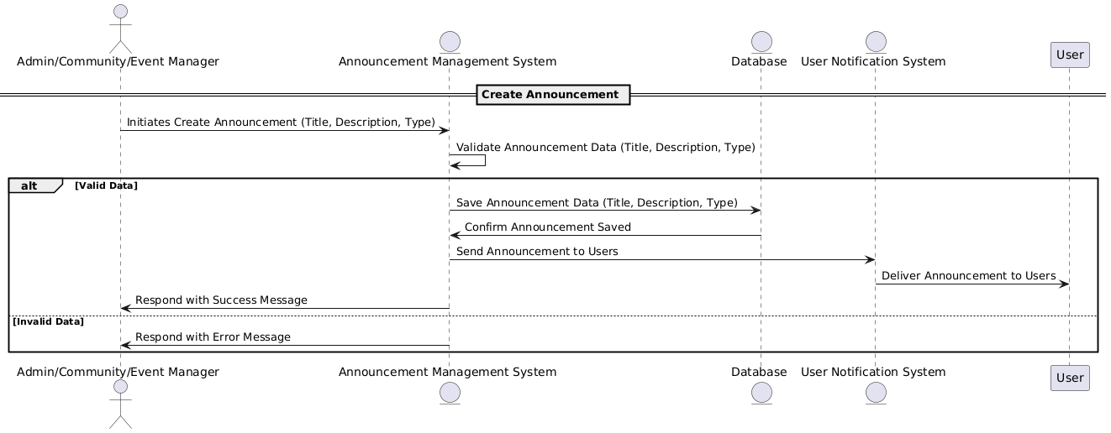

**Database:**

**Functional Requirements (FRs)**

**User Management:**

* **FR1:** The system must allow users to register with a unique username, email, and role (Admin, Manager, etc.).
* **FR2:** The system must store and manage user information, including a creation timestamp.
* **FR3:** Users must be able to log in using their username and email

**Announcement Management**:

* **FR4:** Admin users must be able to create, update, and delete announcements.
* **FR5**: An announcement must have a title, description, type, and timestamps (created_at and sent_at).
* **FR6:** The system must allow admin users to specify the type of announcement (e.g., Event, News, Alert).

**User Notification System**:

* **FR7:** The system must send notifications to users when an announcement is created.
* **FR8**: The system must track the timestamp when each notification is sent.
* **FR9**: Users must receive notifications for announcements that are relevant to them (determined by their role or preferences).
* **FR10**: The system must allow users to view a list of notifications they have received.

**Non-Functional Requirements (NFRs)**

**Performance**:

* **NFR1:** The system should be able to handle at least 1,000 concurrent users creating announcements and receiving notifications.
* **NFR2:** Notifications should be delivered within 5 seconds of announcement creation or update.

**Security**:

* **NFR3:** User data (e.g., username, email) must be encrypted and securely stored.
* **NFR4**: Users should have role-based access control (RBAC) to restrict access to announcements (e.g., only admin users can create/edit announcements).
* **NFR5:** Notifications must be delivered through secure channels (e.g., encrypted email or push notifications).